Project Design Phase

**Solution Architecture**

|  |  |
| --- | --- |
| Date | 13 February 2026 |
| Team ID | LTVIP2026TMIDS65547 |
| Project Name | Explore With Ai: Custom Itineraries For Your Next Journey |
| Maximum Marks | 4 Marks |

**Solution Architecture:**

The solution architecture of *Explore with AI* bridges the gap between the problem of manual travel planning and the implementation of an AI-powered automated system.

The architecture is designed to be lightweight, modular, and scalable. It integrates a web-based user interface with backend application logic and a cloud-based generative AI service.

**Solution Architecture Diagram:**

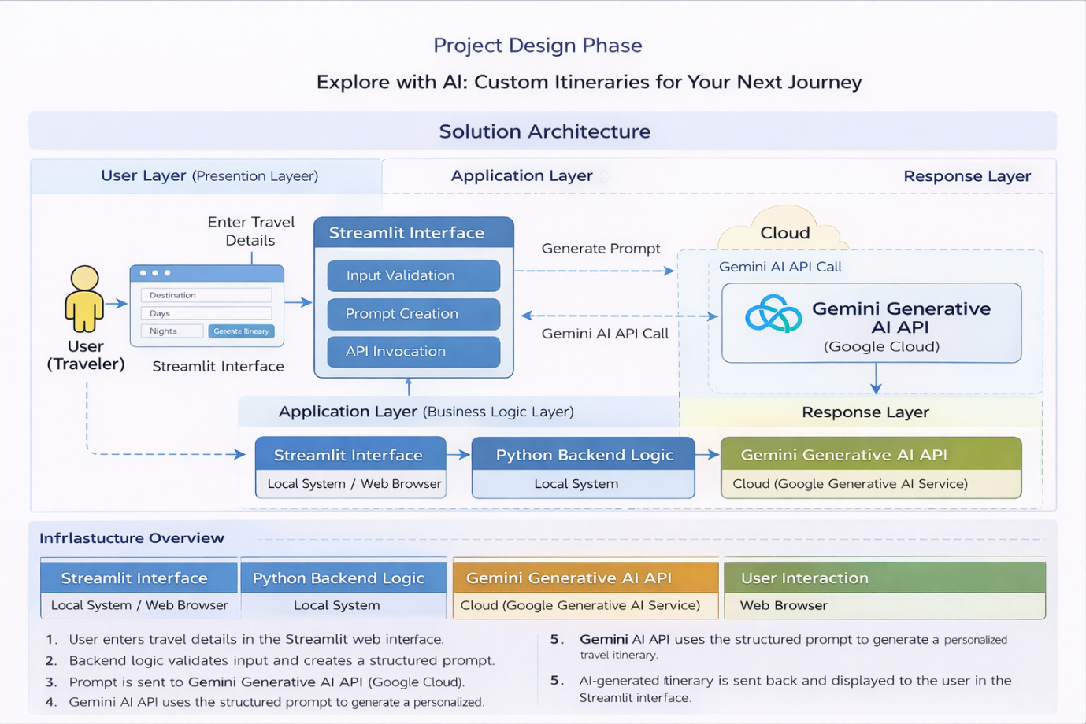

*Figure 1: Architecture and data flow of travel itinerary application*

**Reference:** [**https://aws.amazon.com/blogs/industries/voice-applications-in-clinical-research-powered-by-ai-on-aws-part-1-architecture-and-design-considerations/**](https://aws.amazon.com/blogs/industries/voice-applications-in-clinical-research-powered-by-ai-on-aws-part-1-architecture-and-design-considerations/)